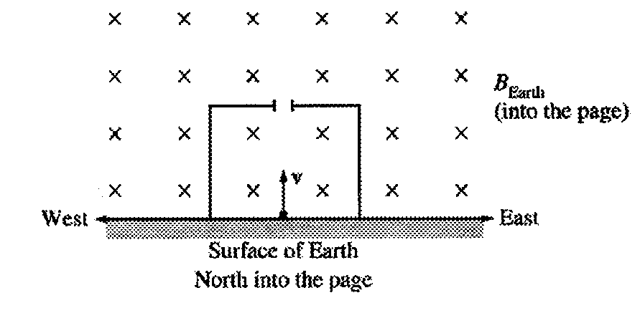

2002B5. (10 points) A proton of mass *mp* and charge *e* is in a box that contains an electric field *E*, and the box is located in Earth's magnetic field *B*. The proton moves with an initial velocity vertically upward from the surface of Earth. Assume gravity is negligible.

(a) On the diagram above, indicate the direction of the electric field inside the box so that there is no change in the trajectory of the proton while it moves upward in the box. Explain your reasoning.

(b) Determine the speed *v* of the proton while in the box if it continues to move vertically upward. Express your answer in terms of the fields and the given quantities.

The proton now exits the box through the opening at the top.

(c) On the diagram above, sketch the path of the proton after it leaves the box.

(d) Determine the magnitude of the acceleration *a* of the proton just after it leaves the box, in terms of the given quantities and fundamental constants.



1996B6 (10 points) Robert Millikan received a Nobel Prize for determining the charge on the electron. To do this, he set up a potential difference between two horizontal parallel metal plates. He then sprayed drops of oil between the plates and adjusted the potential difference until drops of a certain size remained suspended at rest between the plates, as shown above. Suppose that when the potential difference between the plates is adjusted until the electric field is 10,000 N/C downward, a certain drop with a mass of 3.27 x 10-16 kg remains suspended.

a. What is the magnitude of the charge on this drop?

b. The electric field is downward, but the electric force on the drop is upward. Explain why.

c. If the distance between the plates is 0.01 m, what is the potential difference between the plates?

d. The oil in the drop slowly evaporates while the drop is being observed, but the charge on the drop remains the same. Indicate whether the drop remains at rest, moves upward, or moves downward. Explain briefly.

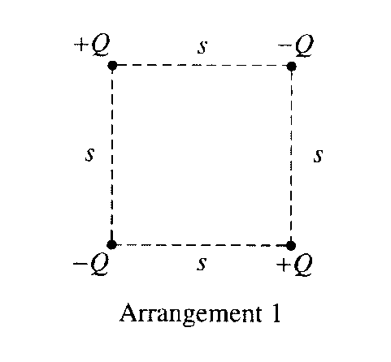

2001B3. Four charged particles are held fixed at the corners of a square of side s. All the charges have the same magnitude Q, but two are positive and two are negative. In Arrangement 1, shown above, charges of the same sign are at opposite corners. Express your answers to parts a. and b. in terms of the given quantities and fundamental constants.

a. For Arrangement 1, determine the following.

i. The electrostatic potential at the center of the square

ii. The magnitude of the electric field at the center of the square

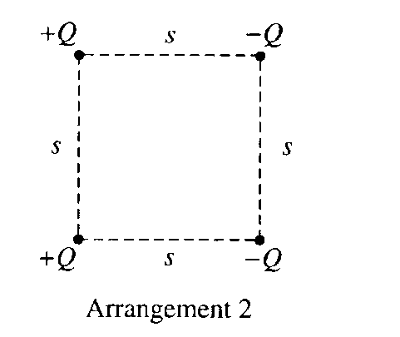

The bottom two charged particles are now switched to form Arrangement 2, shown above, in which the positively charged particles are on the left and the negatively charged particles are on the right.

b. For Arrangement 2, determine the following.

i. The electrostatic potential at the center of the square

ii. The magnitude of the electric field at the center of the square

c. In which of the two arrangements would more work be required to remove the particle at the upper right

corner from its present position to a distance a long way away from the arrangement?

_________ Arrangement 1 ___________ Arrangement 2

Justify your answer

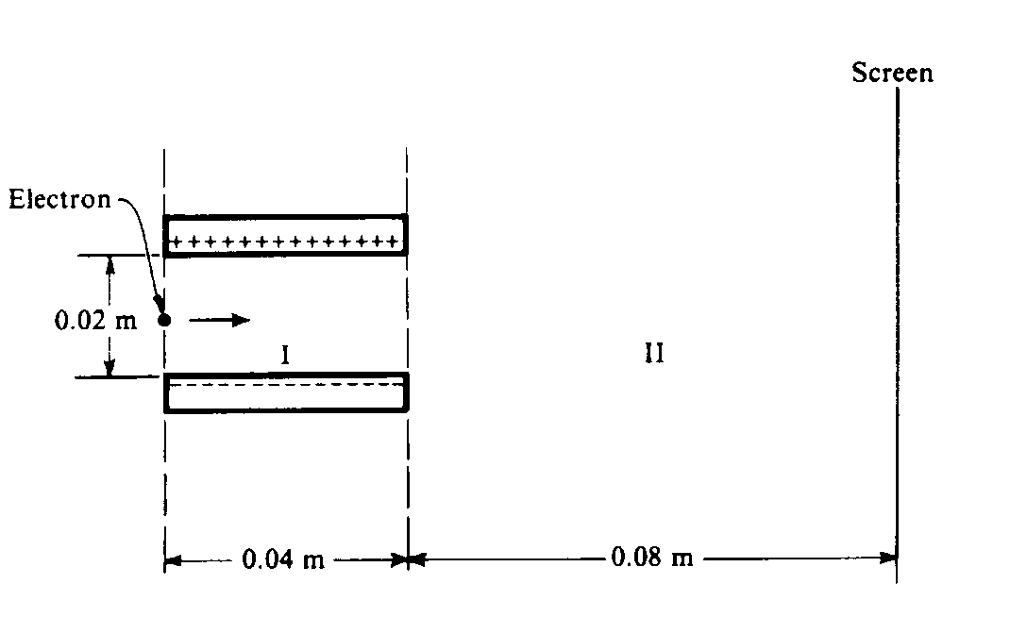

1985B3. An electron initially moves in a horizontal direction and has a kinetic energy of 2.0 x 103 electron‑volts when it is in the position shown above. It passes through a uniform electric field between two oppositely charged horizontal plates (region I) and a field‑free region (region II) before eventually striking a screen at a distance of 0.08 meter from the edge of the plates. The plates are 0.04 meter long and are separated from each other by a distance of 0.02 meter. The potential difference across the plates is 250 volts. Gravity is negligible.

a. Calculate the initial speed of the electron as it enters region I.

b. Calculate the magnitude of the electric field E between the plates, and indicate its direction on the diagram above.

c. Calculate the magnitude of the electric force F acting on the electron while it is in region I.

d. On the diagram below, sketch the path of the electron in regions I and II. For each region describe the shape of the path.

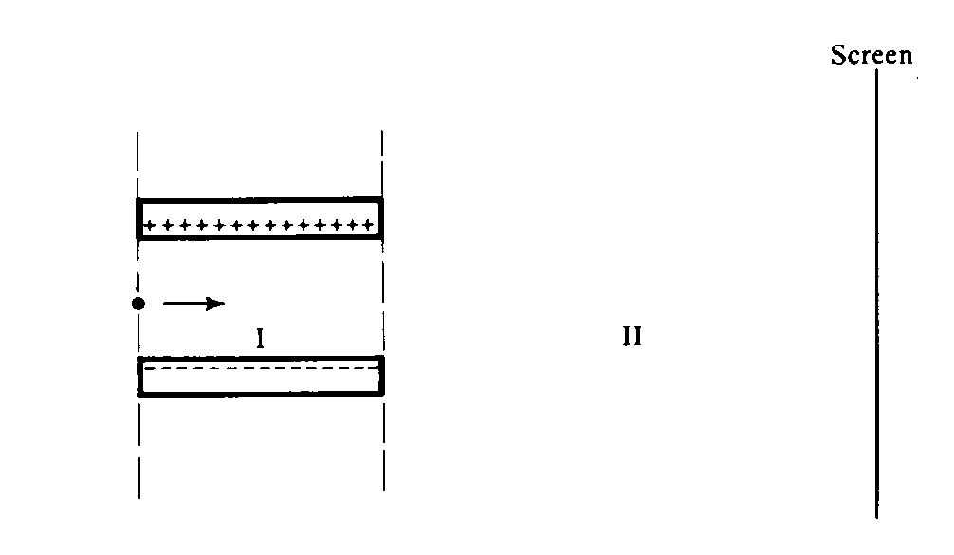



1996B6 (10 points) Robert Millikan received a Nobel Prize for determining the charge on the electron. To do this, he set up a potential difference between two horizontal parallel metal plates. He then sprayed drops of oil between the plates and adjusted the potential difference until drops of a certain size remained suspended at rest between the plates, as shown above. Suppose that when the potential difference between the plates is adjusted until the electric field is 10,000 N/C downward, a certain drop with a mass of 3.27 x 10-16 kg remains suspended.

a. What is the magnitude of the charge on this drop?

b. The electric field is downward, but the electric force on the drop is upward. Explain why.

c. If the distance between the plates is 0.01 m, what is the potential difference between the plates?

d. The oil in the drop slowly evaporates while the drop is being observed, but the charge on the drop remains the same. Indicate whether the drop remains at rest, moves upward, or moves downward. Explain briefly.

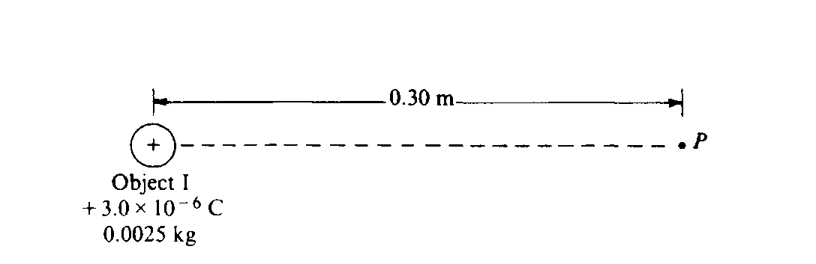

1987B2. Object I, shown above, has a charge of + 3 x 10‑6 coulomb and a mass of 0.0025 kilogram.

a. What is the electric potential at point P, 0.30 meter from object I ?

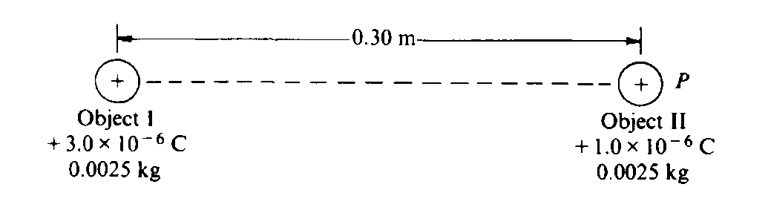

Object II, of the same mass as object I, but having a charge of + 1 x 10‑6 coulomb, is brought from infinity to point P, as shown above.

b. How much work must be done to bring the object II from infinity to point P ?

c. What is the magnitude of the electric force between the two objects when they are 0.30 meter apart?

d. What are the magnitude and direction of the electric field at the point midway between the two objects?

The two objects are then released simultaneously and move apart due to the electric force between them. No other forces act on the objects.

e. What is the speed of object I when the objects are very far apart?